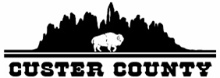

Custer County Commission Special Meeting
Monday, June 19, 2017
420 Mount Rushmore Rd.
Commission Meeting Room
Custer, SD 57730

- Call to Order at 8:00 AM
- Pledge of Allegiance

- Highway Department
- Personnel

- Adjourn
- Adjourn the meeting

Next Meeting Dates: June 28 and July 12, 2017

Custer County fully subscribes to the Americans with Disabilities Act. If you desire to attend this public meeting and are in need of accommodations, please notify the Commissioners’ Office at (605) 673-8173 at least 24 hours prior to the meeting so that appropriate services and auxiliary aids are available.

