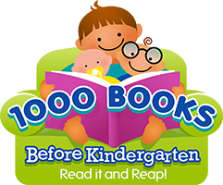

Reading to your child is one of the most powerful ways to boost his or her brain power!

children from birth to age 5
Registration Begins April 1st
Sign up at the
Custer or Hermosa Library
Receive a folder, a reading log, a bookmark, and a book bag to carry home library books.

1,000 Books – That’s less than 3 books a day for 1 year or 1 book a day for 3 years.
You can do it!

