

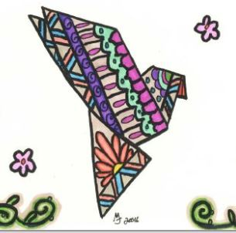

***TRUE COLORS – WEST!***

**Join us on**

**June 21st and**

**July 5th, 12th, & 19th**

**from 5:30 to 7 p.m. at the**

**Custer County Library**

**(447 Crook St.)**

**For Adult Coloring!**

**Children under 18 welcome with adult.**

**Light refreshments provided.**

Color Your Stress Away!

