

Connecting through Coloring!

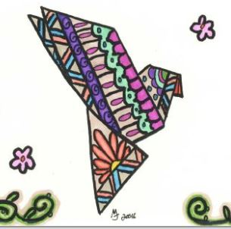

***TRUE COLORS – WEST!***

**Join us on**

**Wednesdays**

**from 5:30 to 7 p.m. at the**

**Custer County Library**

**(447 Crook St.)**

**For coloring and**

**other art activities.**

**Children under 18 welcome with adult.**

