

Color Your Stress Away!

**Join us on**

**August 3rd, 17th, and 31st**

**from 5 to 7 p.m. at the**

**Custer County Library**

**(447 Crook St.)**

**For Adult Coloring!**

**Children under 18 welcome with adult.**

**Light refreshments provided.**

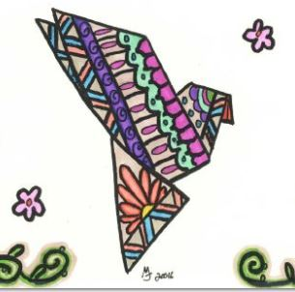

***TRUE COLORS – WEST!***

