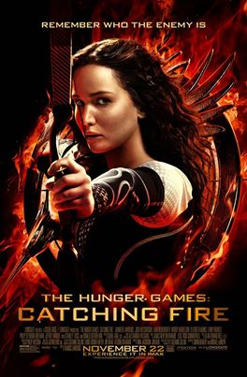
Book Discussion for Teens
Refreshments provided

Followed by a trip to the Carmike to watch
Catching Fire -- the movie!
Read the book!
Discuss the book!
Watch the movie!

November 23rd
2:00 p.m.

Custer County Library
447 Crook St., Suite #4
Catching Fire can be checked out at the Custer County Library or from Ms. Hanna at CHS when available. Sign up at the Library or e-mail cuslib@gwtc.net to participate. You must pre-register by November 9th and attend the book discussion to receive a ticket for the movie.

