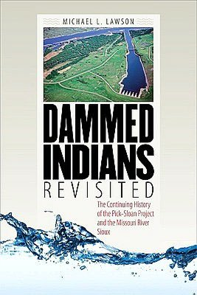
One Book
South Dakota
2012

This program was made possible with a grant from the South Dakota Humanities Council, an affiliate of the National Endowment for the Humanities.
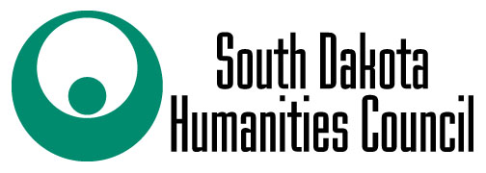

Book Discussion led by Kathy Antonen
Thursday, October 18th @ 4:00 p.m.

Register and pick up your free copy at the
Custer County Library, 447 Crook St.

