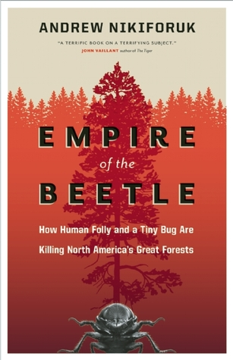
Books
$5 each
while they last!
Sign-up at the
Custer County Library to participate.

Book Discussion
led by
Scholar Kathy Antonen

Thursday, April 11th
6:00 p.m.

Custer County Library
447 Crook St., Suite #4

