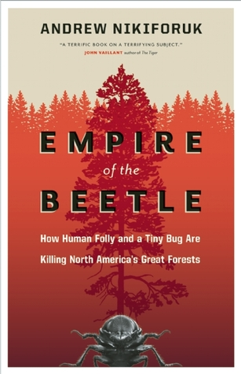
Sign-up at the
Custer County Library to participate.
Books
$5 each
while they last!

Thursday, April 11th
6:00 p.m.

Custer County Library
447 Crook St., Suite #4

Book Discussion led by Scholar Kathy Antonen

Event sponsored by
the Custer County Library
and the Bark Beetle Blues Committee

