**Exploring Home:**

**A Place Based Writing Workshop**

**with Ken Steinken**

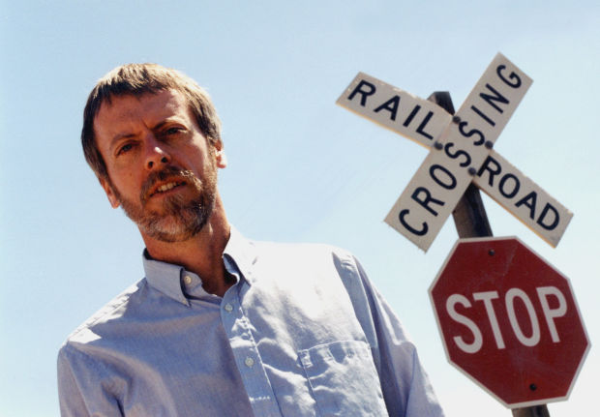

Custer County Library

January 17, 2014

1 – 4 p.m.

Open yourself up to find inspiration to write no matter where you have landed in life.

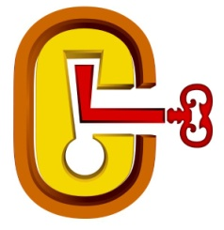

Custer County Library

447 Crook St., Suite #4

605-673-4803

