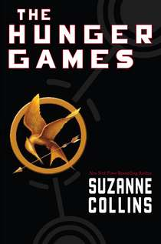
Book Discussion @ 1:00 p.m
Refreshments provided!

Followed by a trip to the Carmike 10 to watch
The Hunger Games movie!
Read the book!
Discuss the book!
Watch the movie!

Friday, March 30th
1:00 p.m.

Custer County Library
447 Crook St., Suite #4
The Hunger Games book can be checked out at the Custer County Library when available. Sign up at the Library or e-mail cuslib@gwtc.net to participate. If you need transportation, please let us know before March 26th.

