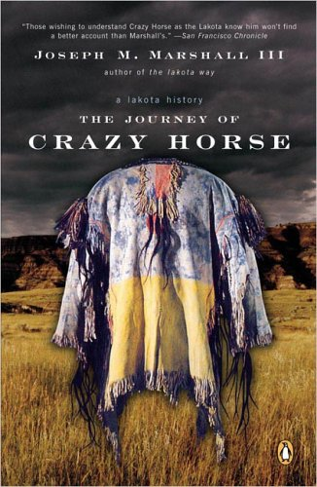

One Book
South Dakota
2011

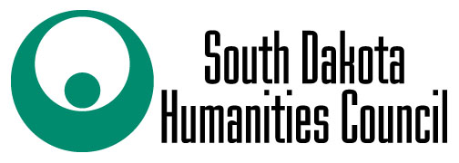
This program was made possible with a grant from the South Dakota Humanities Council, an affiliate of the National Endowment for the Humanities.

Book Discussion led by Kathy Antonen
Monday, October 3rd @ 5:30 p.m.

Register and pick up your free copy at the
Custer County Library, 447 Crook St.

