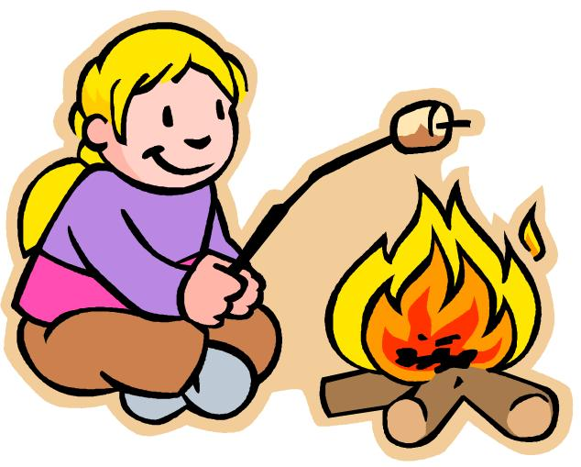

Thursday, May 31st @ 7:00 p.m.
Custer Lutheran Fellowship Campfire Circle
12622 Hwy. 16A
Spend the evening around the
campfire with your family.

Enjoy hot dogs, s’mores, and storytelling!

Featuring
Native American Storyteller
Belinda Joe

