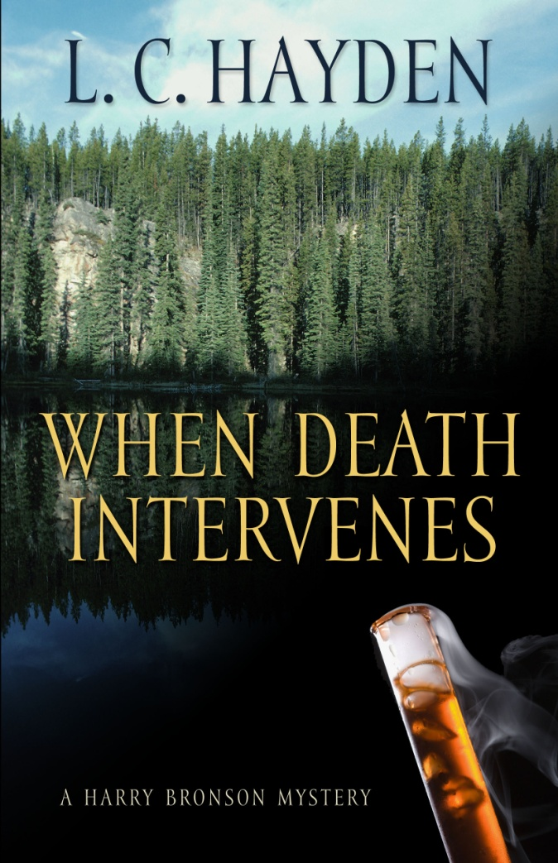

Presentation &
Book Signing
By
Author L. C. Hayden

Custer County Library
Conference Room
June 18th @ 2:00 p.m.

L. C. Hayden is an award winning author. Her Harry Bronson Series Mystery, Why Casey Had to Die, was an Agatha Award Finalist for Best Mystery.

When Death Intervenes is another Harry Bronson Mystery featuring scenes at the Purple Pie Place and the Roost Resort Campground in Custer.

Drop by the Library to enjoy a humorous presentation by Hayden as well as the opportunity to ask questions about writing and getting published. Hayden will also be selling and signing her books.

