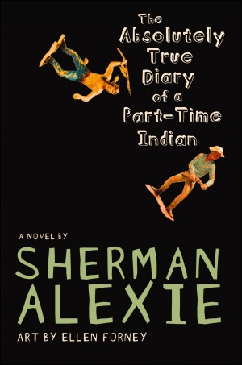
This program was made possible with a grant from the South Dakota Humanities Council, an affiliate of the National Endowment for the Humanities.
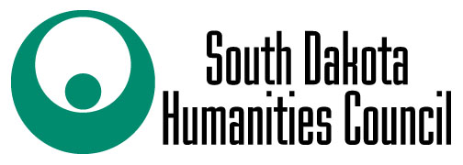
Junior, a budding cartoonist growing up on the Spokane Indian Reservation is determined to take his future into his own hands. He leaves his troubled school on the rez to attend an all-white farm town high school where the only other Indian is the school mascot. Despite being condemned as a traitor to his people, Junior attacks life with wit and humor. Inspired by his own experiences growing up, Sherman Alexie chronicles the contemporary adolescence of one Native American boy as he attempts to rise above the life everyone expects him to live.

Book Discussion led by Kathy Antonen
Thursday, April 19th @ 4:00 p.m.

Register and pick up your free copy at the
Custer County Library, 447 Crook St.

