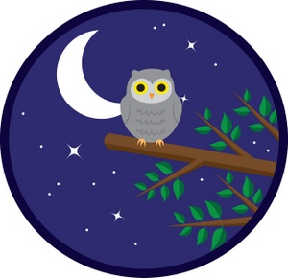

The Black Hill Storytellers &
The French Creek Folk

Enjoy an evening
of tales and songs
of the night!

Saturday, April 14th @ 7:00 p.m.
in the Pine Room
447 Crook St.
Custer, SD
A Storytelling Event for Adults
FREE Admission
Refreshments

