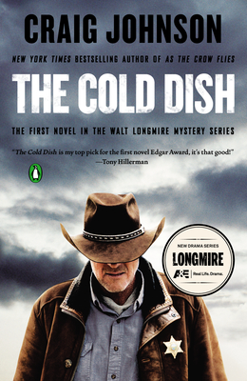
Books
$5 each
while they last!
Sign-up at the
Custer County Library to participate.

Book Discussion with Special Guest
Craig Johnson!

Saturday, may 4th
5:00 p.m.

Custer County Library
447 Crook St., Suite #4
605-673-4803

