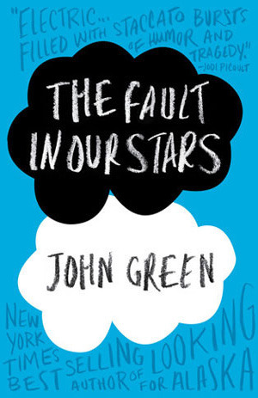
Sign-up at the
Custer County Library to participate.

Books
$5 each
while they last!

Thursday, April 3rd
6:00 p.m.

Custer County Library
447 Crook St., Suite #4
605-673-4803

