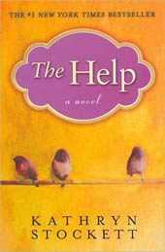
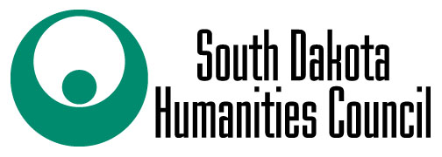

This program was made possible with a grant from the South Dakota Humanities Council, an affiliate of the National Endowment for the Humanities.

Book Discussion led by Kathy Antonen
Monday, November 7th @ 5:30 p.m.

Custer County Library
447 Crook St., Suite #4

