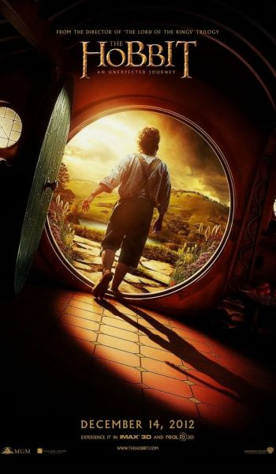
Read the book!
Discuss the book!
Watch the movie!
Book Discussion @ 12:30 p.m
Refreshments provided!

Followed by a trip to the Carmike to watch
The Hobbit movie!

Saturday, December 15th
12:30 p.m.

Custer County Library
447 Crook St., Suite #4
The Hobbit can be checked out at the Custer County Library when available. Sign up at the Library or e-mail cuslib@gwtc.net to participate. If you need transportation, please let us know before November 21st.

