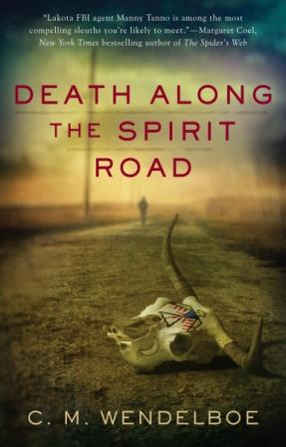
Books -- $5 each while they last!
Sign-up at the
Custer County Library to participate.

Book Discussion led by
Author C.M. Wendelboe

Friday, March 23rd
3:30 p.m.

Custer County Library
447 Crook St., Suite #4

