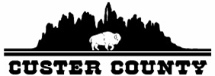

Custer County Special Commission Meeting
Tuesday, April 6, 2021
420 Mount Rushmore Rd.
Commission Meeting Room
Custer, SD 57730

- Call to Order at 9:00 A.M.
- Pledge of Allegiance

- Approval of Agenda

- Conflict of Interest Declaration

- Director of Equalization
- Pursuant to SDCL 10-3-14 for annual conference of commissioners and director

- Adjourn
- Adjourn the meeting

Next Meeting Dates: April 14th & 28th, 2021

Custer County fully subscribes to the Americans with Disabilities Act. If you desire to attend this public meeting and are in need of accommodations, please notify the Commissioners’ Office at (605) 673-8173 at least 24 hours prior to the meeting so that appropriate services and auxiliary aids are available.

