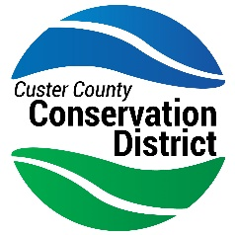
Custer County Conservation District
25363 US Hwy 385
Custer, SD 57730
605-673-5680
custercd@sdconservation.net

2023 Custer County Conservation Youth Scholarship Program

Custer County Conservation District is once again awarding scholarships to high school seniors who reside in Custer County. This year we have $1,000 scholarships available for 2 qualified applicants. Students should demonstrate an interest in conservation and submit the following:
- Essay of at least 250 words on one of the following topics:
  - Describe your interest in natural resources or the importance of natural resources in conservation.
  - Name a resource concern in Custer County, and any practices you may have witnessed, or proposals you have to help remedy that resource concern.
    - Visit www.sdresourceconcerns.org for information on resource concerns in South Dakota.
- Completed application (see attached).
- Student photo.
Applications are due by 5:00 PM on March 31, 2023. Please email completed application and essay along with digital photo to Mike Baldwin at custercd@sdconservation.net. If unable to submit via email, please contact the office at 673-5680.
Thank you for your interest in this scholarship and Good Luck!

Sincerely,

Mike Baldwin, District Manager

Custer County Conservation District
Scholarship Application

- Student’s Full Name:

- Student’s Address:

Phone Number:
Email Address:

- Name of Parents:

- Awards, Honors, Offices in High School:

- Extra-Curricular and Community Activities, Honors:

- Any awards, medals, or recognition earned relating to conservation:

- College or Vocational School you plan to attend:

- What major course of study do you intend to pursue:

Signature of applicant:

